**Cognizant_Digital Nurture 4.0_Deep Skilling**

**Products and Frameworks**

**Module 7 - Spring REST using Spring Boot 3**

**Create a Spring Web Project using Maven**

**SpringlearnApplication.java**

package com.cognizant.springlearn;

import org.springframework.boot.SpringApplication;

import org.springframework.boot.autoconfigure.SpringBootApplication;

*@SpringBootApplication*

public class SpringlearnApplication {

public static void main(String[] args) {

System.***out***.println("SpringLearnApplication Started");

SpringApplication.*run*(SpringlearnApplication.class, args);

}

}

**application.properties**

spring.application.name=springlearn

server.port=8090

server.servlet.context-path=/spring-learn

spring.application.name=spring-learn

logging.level.root=INFO

logging.level.com.cognizant=DEBUG

spring.devtools.restart.enabled=true

**springlearn/pom.xml**

<?xml version="1.0" encoding="UTF-8"?>

<project xmlns="http://maven.apache.org/POM/4.0.0"

xmlns:xsi="http://www.w3.org/2001/XMLSchema-instance"

xsi:schemaLocation="http://maven.apache.org/POM/4.0.0 https://maven.apache.org/xsd/maven-4.0.0.xsd">

<modelVersion>4.0.0</modelVersion>

<parent>

<groupId>org.springframework.boot</groupId>

<artifactId>spring-boot-starter-parent</artifactId>

<version>3.5.3</version>

<relativePath/> <!-- lookup parent from repository -->

</parent>

<groupId>com.cognizant</groupId>

<artifactId>springlearn</artifactId>

<version>0.0.1-SNAPSHOT</version>

<name>springlearn</name>

<description>Demo project for Spring Boot</description>

<properties>

<java.version>17</java.version>

</properties>

<dependencies>

<!-- Spring Boot Web dependency -->

<dependency>

<groupId>org.springframework.boot</groupId>

<artifactId>spring-boot-starter-web</artifactId>

</dependency>

<!-- Spring Boot DevTools for hot reload -->

<dependency>

<groupId>org.springframework.boot</groupId>

<artifactId>spring-boot-devtools</artifactId>

<scope>runtime</scope>

<optional>true</optional>

</dependency>

<!-- Spring Boot Starter Test -->

<dependency>

<groupId>org.springframework.boot</groupId>

<artifactId>spring-boot-starter-test</artifactId>

<scope>test</scope>

</dependency>

</dependencies>

<build>

<plugins>

<plugin>

<groupId>org.springframework.boot</groupId>

<artifactId>spring-boot-maven-plugin</artifactId>

</plugin>

</plugins>

</build>

</project>

**HelloController.java**

package com.cognizant.springlearn;

import org.springframework.web.bind.annotation.GetMapping;

import org.springframework.web.bind.annotation.RestController;

*@RestController*

public class HelloController {

*@GetMapping*("/hello")

public String sayHello() {

return "Hello, World!";

}

}

**Output:**

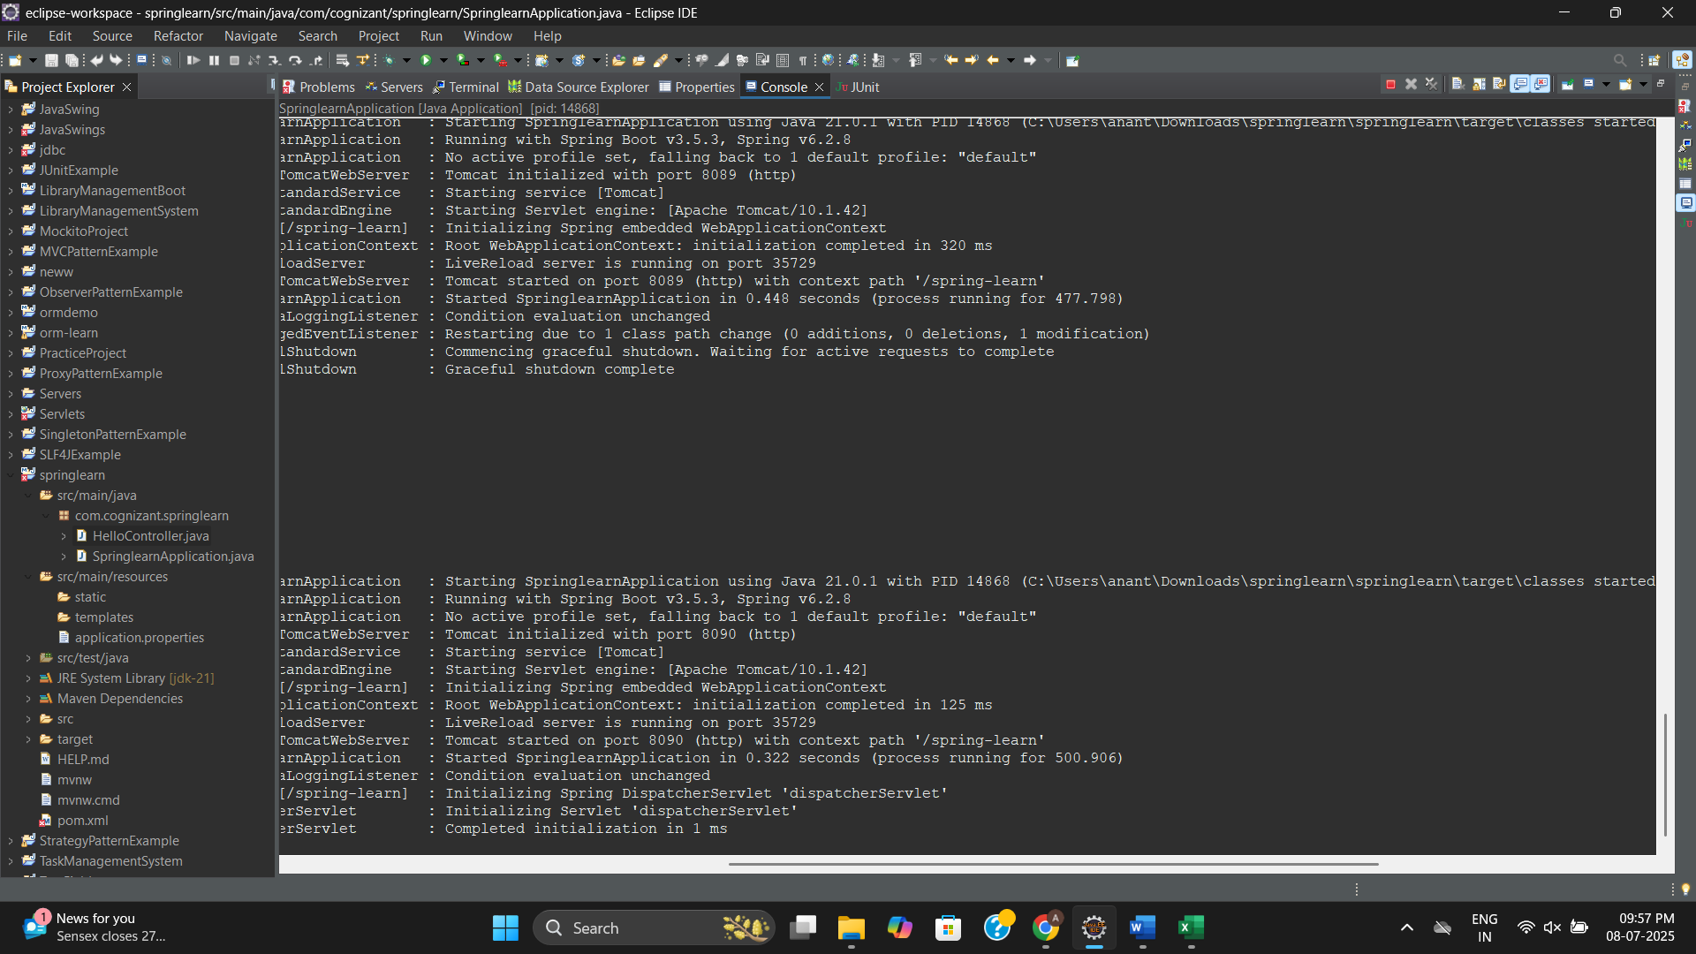

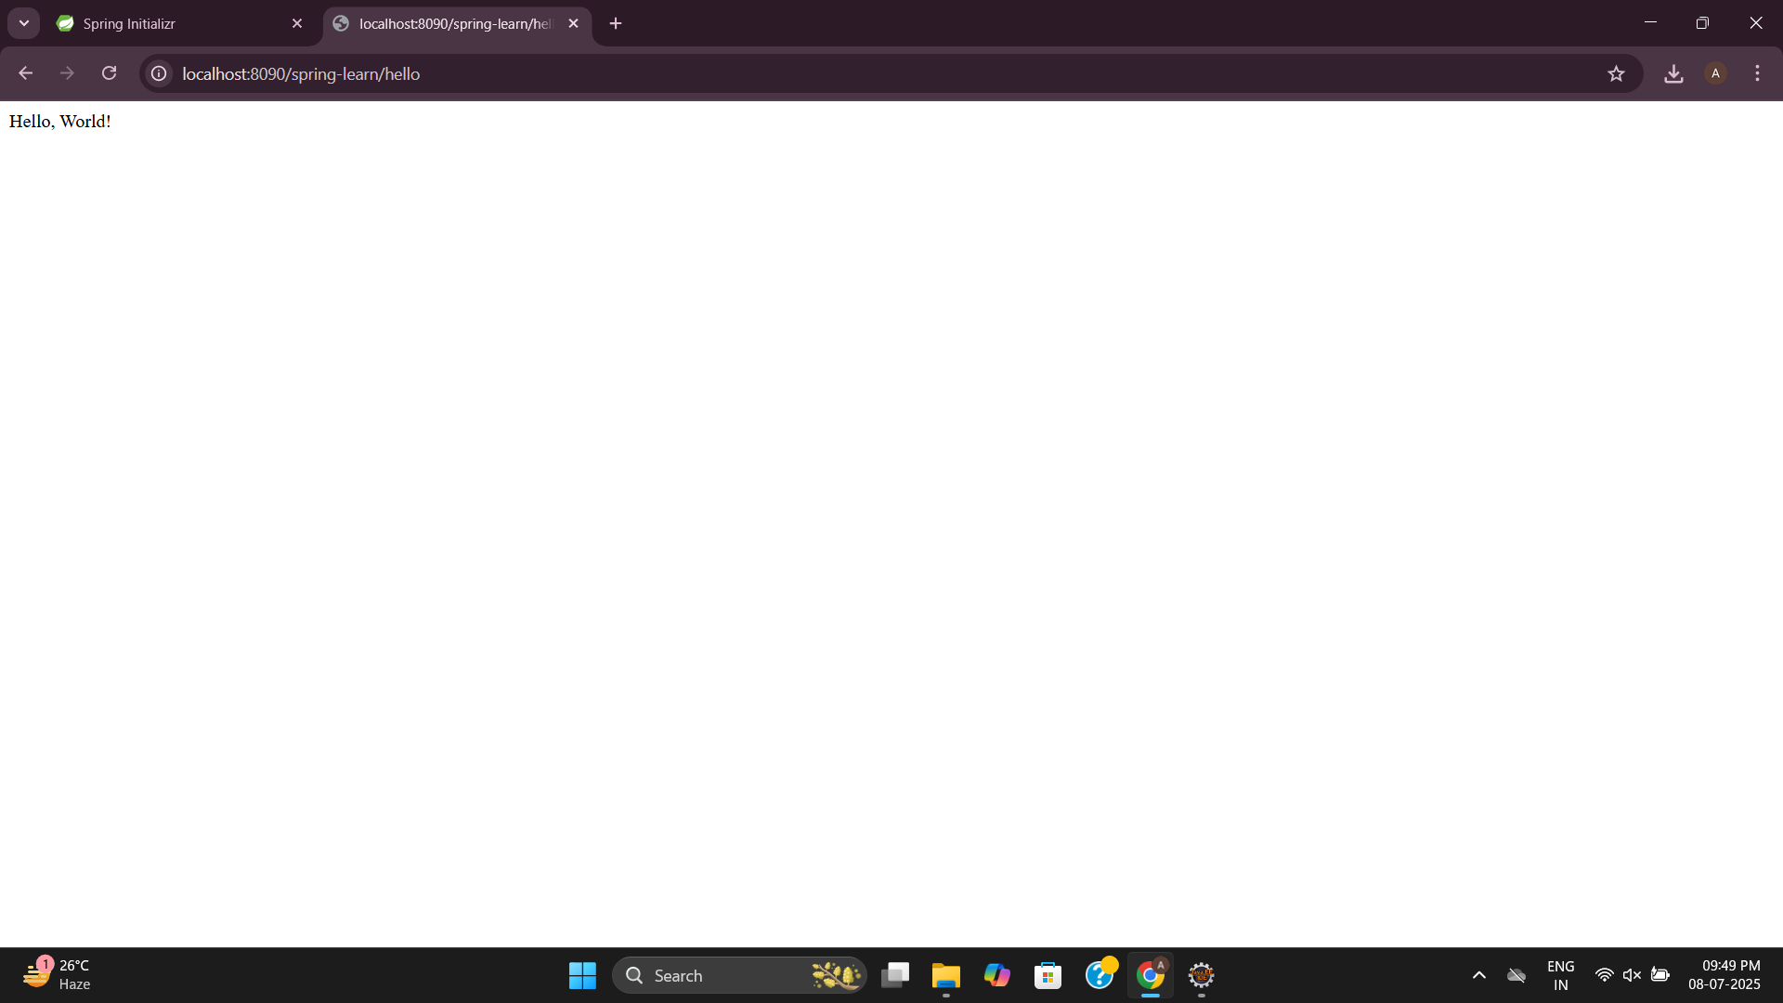

**Spring Core – Load Country from Spring Configuration XML**

**Country.java**

package com.cognizant.springcorexml;

import org.slf4j.Logger;

import org.slf4j.LoggerFactory;

public class Country {

private static final Logger ***LOGGER*** = LoggerFactory.*getLogger*(Country.class);

private String code;

private String name;

public Country() {

***LOGGER***.debug("Inside Country Constructor.");

}

public String getCode() {

***LOGGER***.debug("Inside getCode");

return code;

}

public void setCode(String code) {

***LOGGER***.debug("Inside setCode");

this.code = code;

}

public String getName() {

***LOGGER***.debug("Inside getName");

return name;

}

public void setName(String name) {

***LOGGER***.debug("Inside setName");

this.name = name;

}

*@Override*

public String toString() {

return "Country{code='" + code + "', name='" + name + "'}";

}

}

**country.xml**

<?**xml** version=*"1.0"* encoding=*"UTF-8"*?>

<**beans** xmlns=*"http://www.springframework.org/schema/beans"*

xmlns:xsi=*"http://www.w3.org/2001/XMLSchema-instance"*

xsi:schemaLocation=*"http://www.springframework.org/schema/beans*

*https://www.springframework.org/schema/beans/spring-beans.xsd"*>

<**bean** id=*"countryList"* class=*"java.util.ArrayList"*>

<**constructor-arg**>

<**list**>

<**bean** class=*"com.cognizant.springcorexml.Country"*>

<**property** name=*"code"* value=*"US"*/>

<**property** name=*"name"* value=*"United States"*/>

</**bean**>

<**bean** class=*"com.cognizant.springcorexml.Country"*>

<**property** name=*"code"* value=*"DE"*/>

<**property** name=*"name"* value=*"Germany"*/>

</**bean**>

<**bean** class=*"com.cognizant.springcorexml.Country"*>

<**property** name=*"code"* value=*"IN"*/>

<**property** name=*"name"* value=*"India"*/>

</**bean**>

<**bean** class=*"com.cognizant.springcorexml.Country"*>

<**property** name=*"code"* value=*"JP"*/>

<**property** name=*"name"* value=*"Japan"*/>

</**bean**>

</**list**>

</**constructor-arg**>

</**bean**>

</**beans**>

**SpringcorexmlApplication.java**

package com.cognizant.springcorexml;

import org.slf4j.Logger;

import org.slf4j.LoggerFactory;

import org.springframework.context.ApplicationContext;

import org.springframework.context.support.ClassPathXmlApplicationContext;

import java.util.List;

public class SpringcorexmlApplication {

private static final Logger ***LOGGER*** = LoggerFactory.*getLogger*(SpringcorexmlApplication.class);

public static void main(String[] args) {

*displayIndia*();

}

public static void displayIndia() {

ApplicationContext context = new ClassPathXmlApplicationContext("country.xml");

*@SuppressWarnings*("unchecked")

List<Country> countries = (List<Country>) context.getBean("countryList");

for (Country country : countries) {

if ("IN".equals(country.getCode())) {

***LOGGER***.debug("Found India: {}", country);

System.***out***.println(country);

}

}

}

}

**Output:**

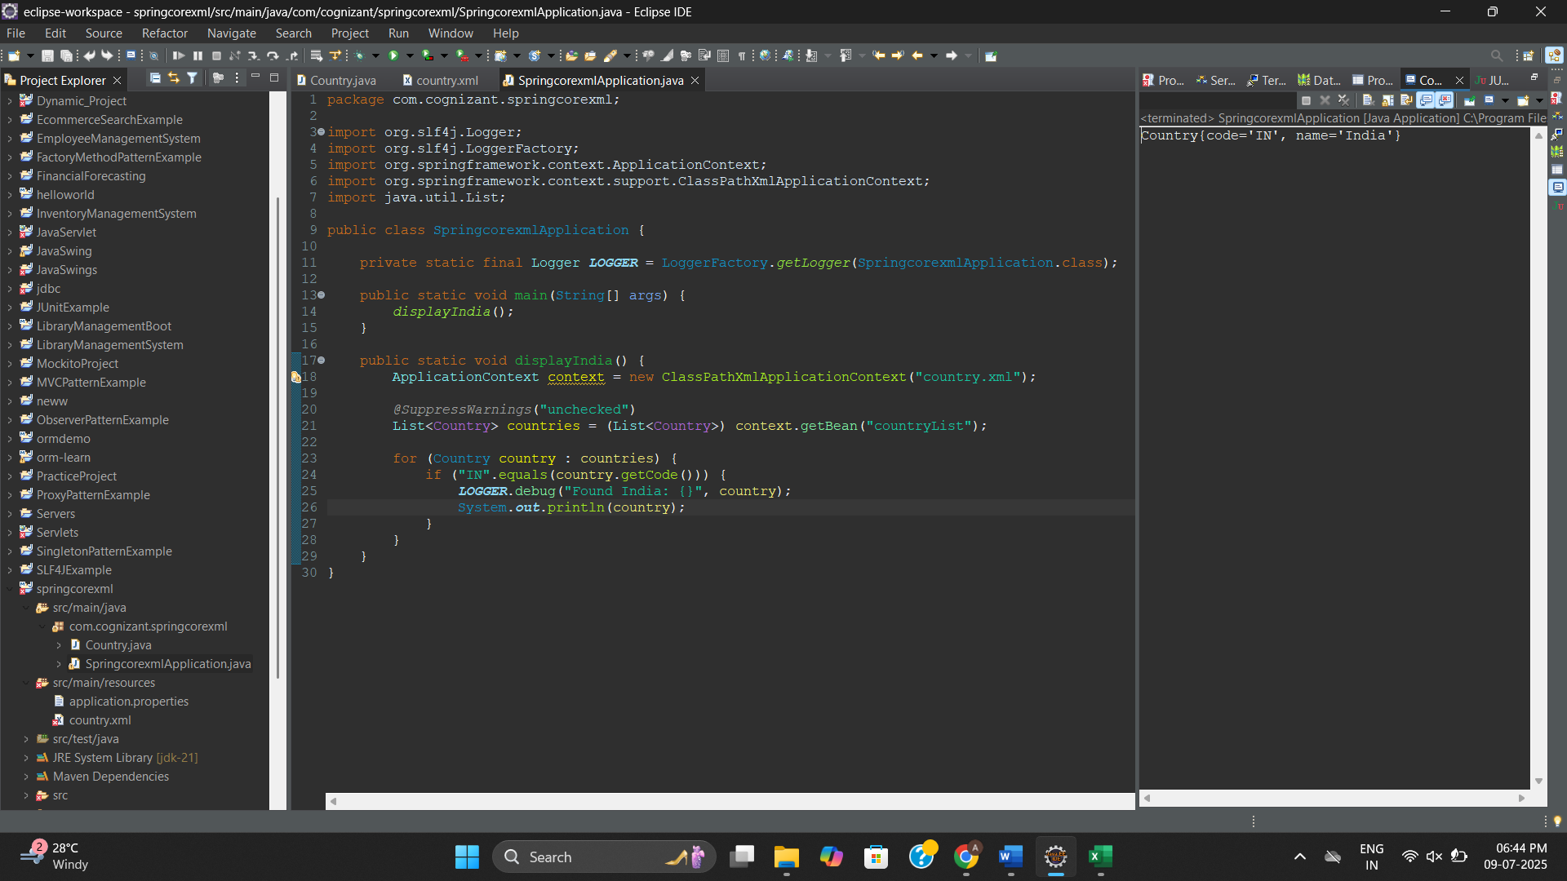

**Hello World RESTful Web Service**

**HelloController.java**

package com.cognizant.spring_learn.controller;

import org.slf4j.Logger;

import org.slf4j.LoggerFactory;

import org.springframework.web.bind.annotation.GetMapping;

import org.springframework.web.bind.annotation.RestController;

*@RestController*

public class HelloController {

private static final Logger ***LOGGER*** = LoggerFactory.*getLogger*(HelloController.class);

*@GetMapping*("/hello")

public String sayHello() {

***LOGGER***.info("START: sayHello()");

String response = "Hello World!!";

***LOGGER***.info("END: sayHello()");

return response;

}

}

**SpringLearnApplication.java**

package com.cognizant.spring_learn;

import org.springframework.boot.SpringApplication;

import org.springframework.boot.autoconfigure.SpringBootApplication;

*@SpringBootApplication*

public class SpringLearnApplication {

public static void main(String[] args) {

SpringApplication.*run*(SpringLearnApplication.class, args);

}

}

**Output:**

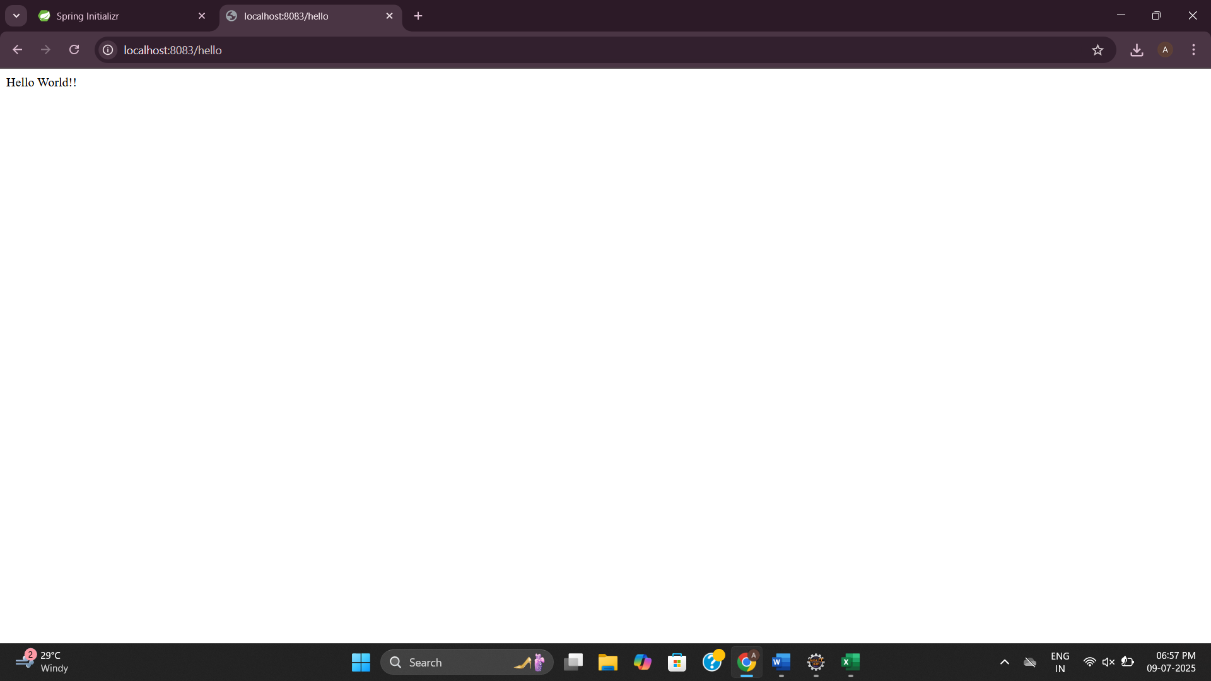

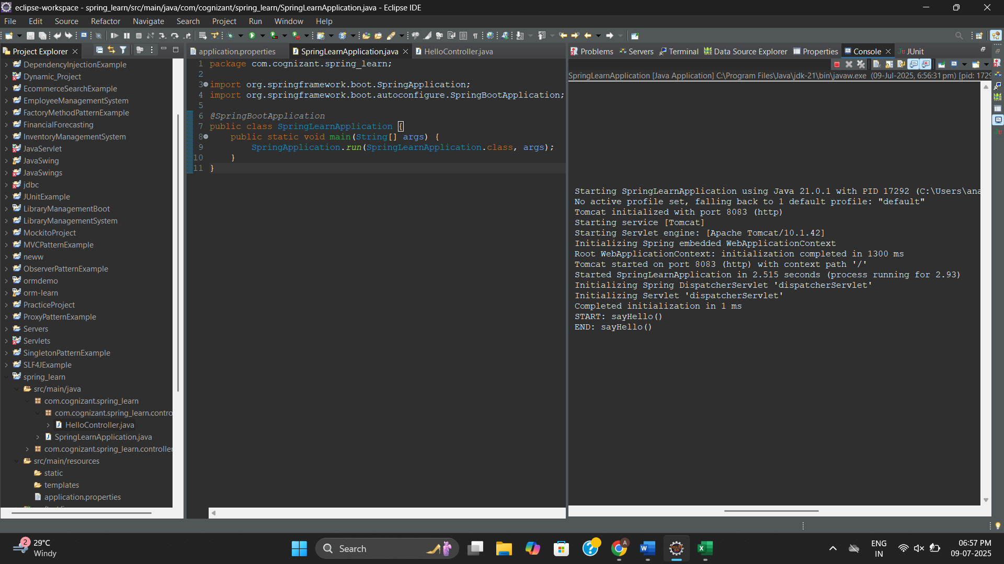

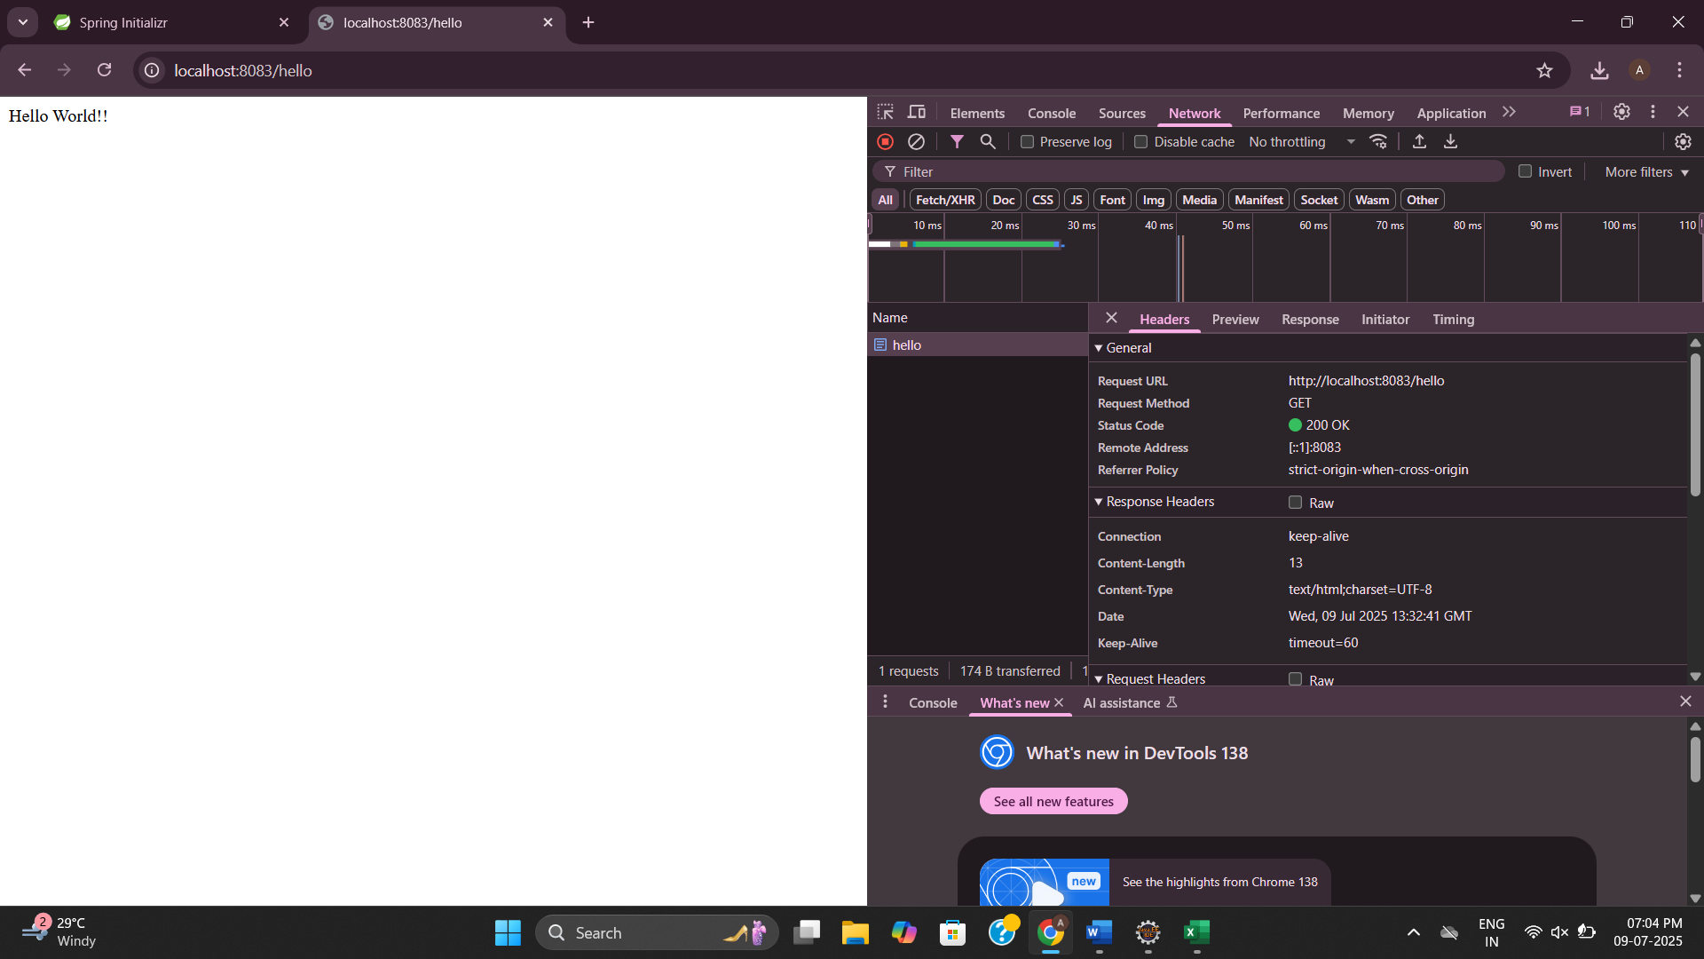

**REST - Country Web Service**

**CountryController.java**

package com.cognizant.spring_learn.controller;

import com.cognizant.spring_learn.Country;

import org.slf4j.Logger;

import org.slf4j.LoggerFactory;

import org.springframework.context.ApplicationContext;

import org.springframework.context.support.ClassPathXmlApplicationContext;

import org.springframework.web.bind.annotation.RequestMapping;

import org.springframework.web.bind.annotation.RestController;

*@RestController*

public class CountryController {

private static final Logger ***LOGGER*** = LoggerFactory.*getLogger*(CountryController.class);

*@RequestMapping*("/country")

public Country getCountryIndia() {

***LOGGER***.info("START - getCountryIndia()");

ApplicationContext context = new ClassPathXmlApplicationContext("country.xml");

Country country = context.getBean("country", Country.class);

***LOGGER***.info("END - getCountryIndia()");

return country;

}

}

**Country.java**

package com.cognizant.spring_learn;

public class Country {

private String code;

private String name;

public Country() {

System.***out***.println("Inside Country Constructor");

}

public String getCode() {

System.***out***.println("Inside getCode");

return code;

}

public void setCode(String code) {

System.***out***.println("Inside setCode");

this.code = code;

}

public String getName() {

System.***out***.println("Inside getName");

return name;

}

public void setName(String name) {

System.***out***.println("Inside setName");

this.name = name;

}

*@Override*

public String toString() {

return "Country{" + "code='" + code + '\'' + ", name='" + name + '\'' + '}';

}

}

**country.xml**

<?**xml** version=*"1.0"* encoding=*"UTF-8"*?>

<**beans** xmlns=*"http://www.springframework.org/schema/beans"*

xmlns:xsi=*"http://www.w3.org/2001/XMLSchema-instance"*

xsi:schemaLocation=*"http://www.springframework.org/schema/beans*

*https://www.springframework.org/schema/beans/spring-beans.xsd"*>

<**bean** id=*"country"* class=*"com.cognizant.spring_learn.Country"*>

<**property** name=*"code"* value=*"IN"* />

<**property** name=*"name"* value=*"India"* />

</**bean**>

</**beans**>

**SpringLearnApplication.java**

package com.cognizant.spring_learn;

import org.springframework.boot.SpringApplication;

import org.springframework.boot.autoconfigure.SpringBootApplication;

*@SpringBootApplication*

public class SpringLearnApplication {

public static void main(String[] args) {

SpringApplication.*run*(SpringLearnApplication.class, args);

}

}

**Output:**

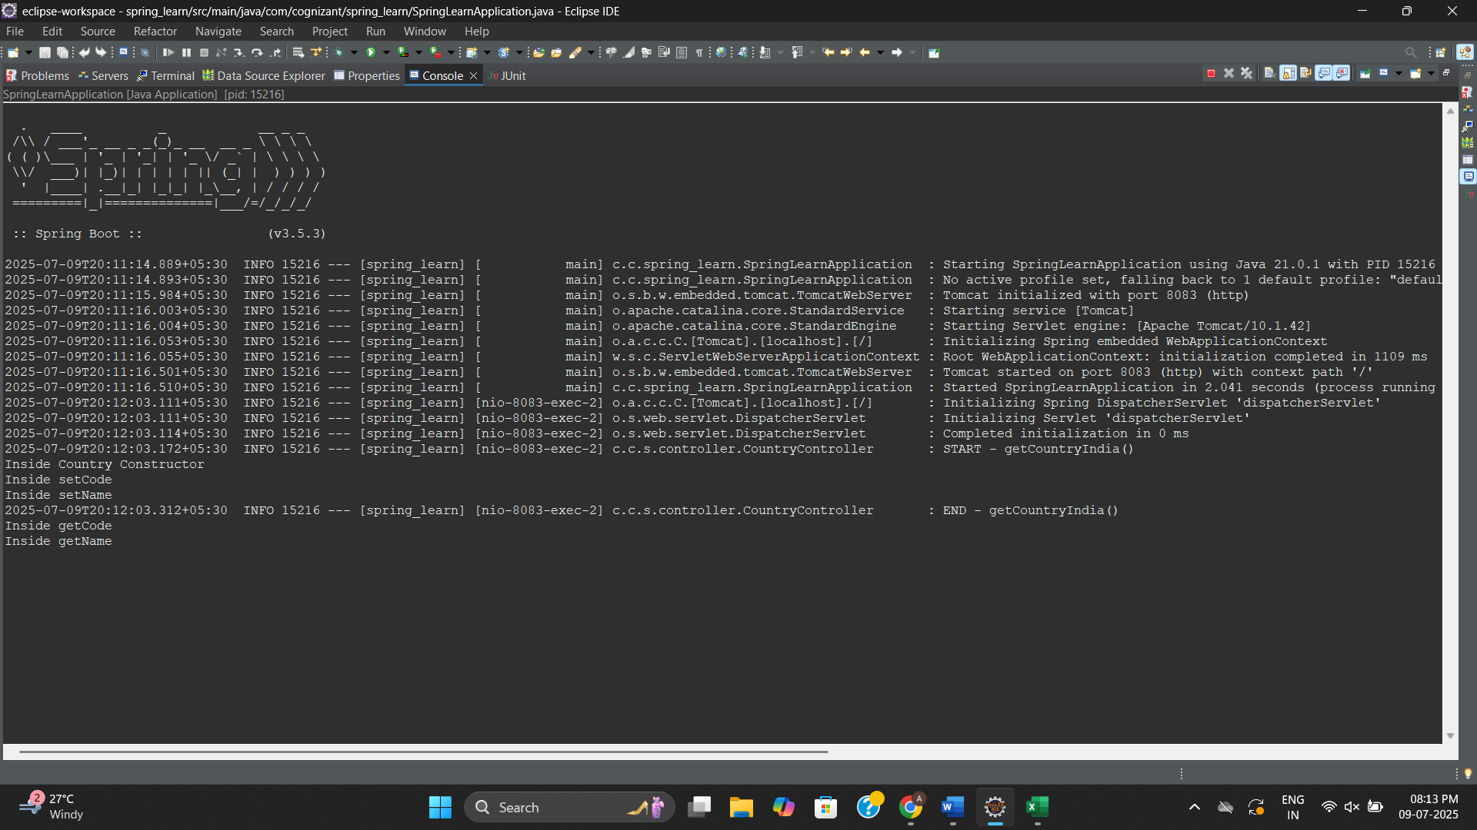

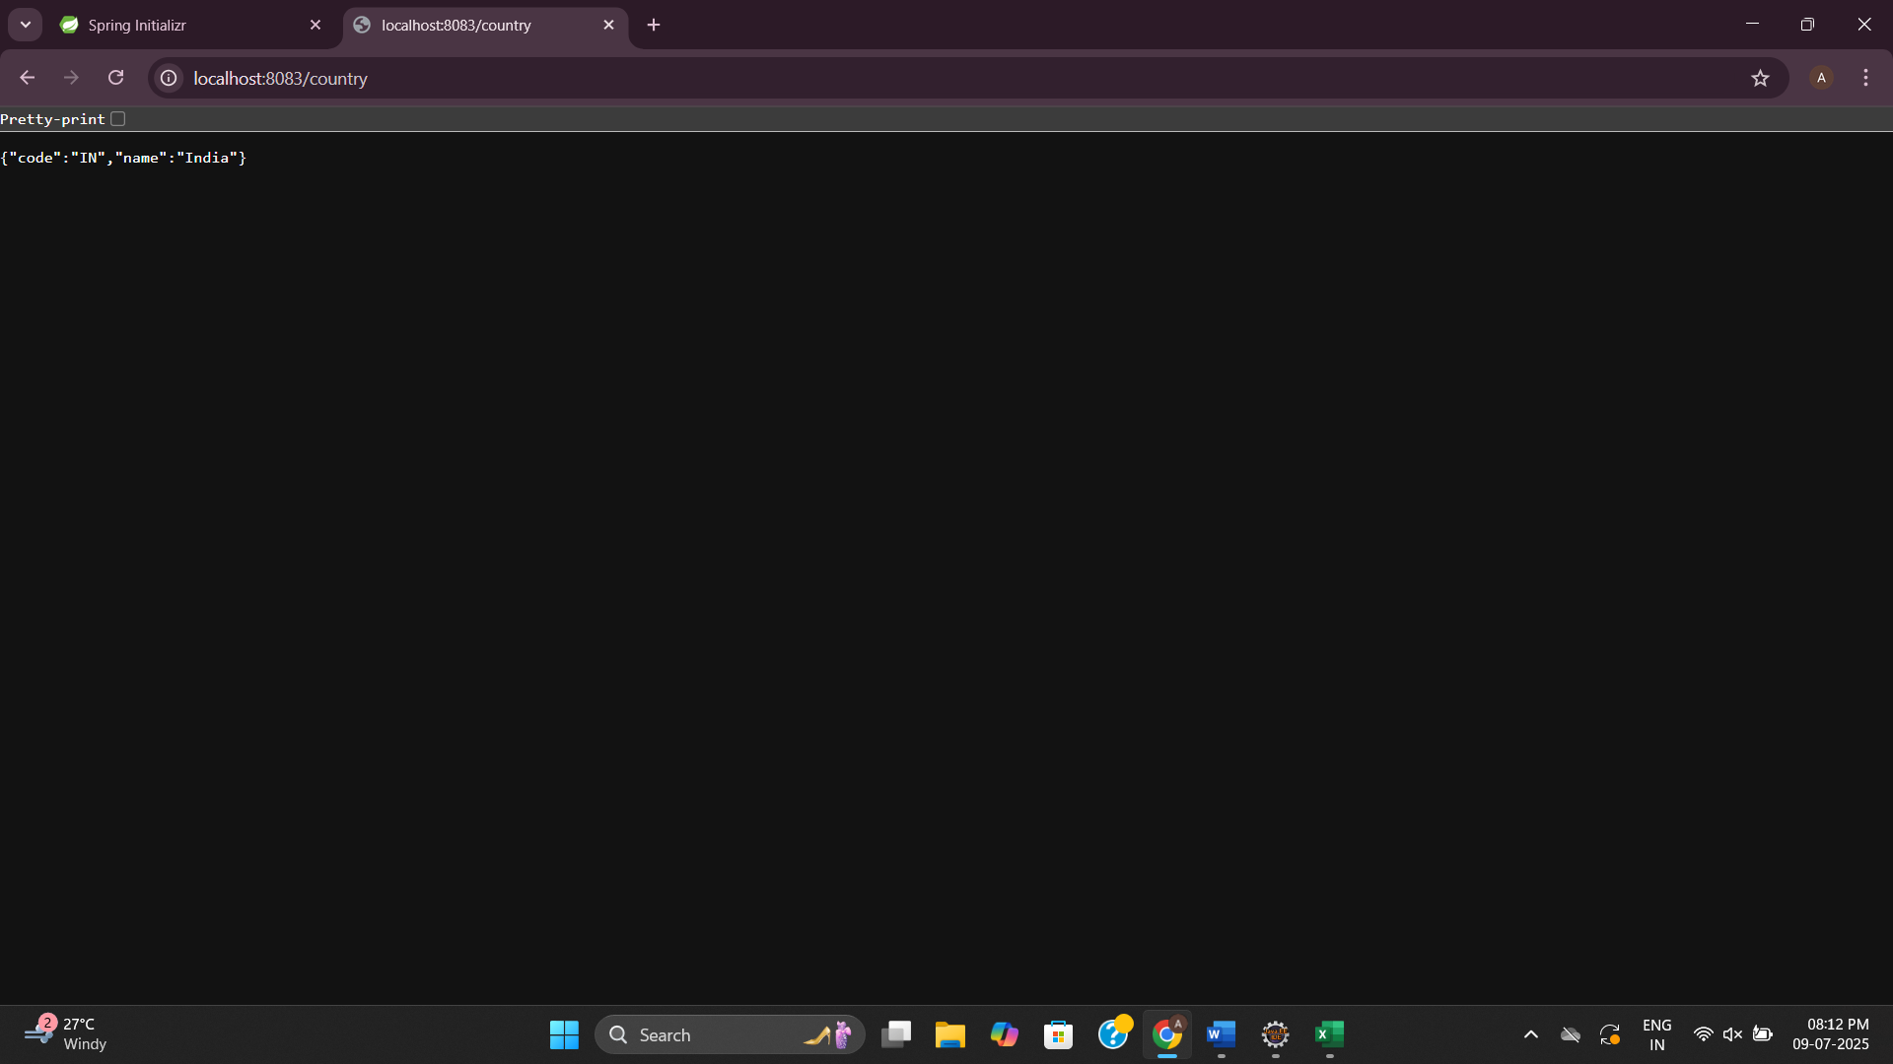

**REST - Get country based on country code**

**CountryController.java**

package com.cognizant.spring_learn.controller;

import com.cognizant.spring_learn.Country;

import com.cognizant.spring_learn.service.CountryService;

import org.springframework.beans.factory.annotation.Autowired;

import org.springframework.web.bind.annotation.*;

*@RestController*

public class CountryController {

*@Autowired*

private CountryService countryService;

*@GetMapping*("/country/{code}")

public Country getCountry(*@PathVariable* String code) {

return countryService.getCountry(code);

}

}

**CountryService.java**

package com.cognizant.spring_learn.service;

import com.cognizant.spring_learn.Country;

import org.springframework.context.ApplicationContext;

import org.springframework.context.support.ClassPathXmlApplicationContext;

import org.springframework.stereotype.Service;

import java.util.List;

*@Service*

public class CountryService {

public Country getCountry(String code) {

ApplicationContext context = new ClassPathXmlApplicationContext("country.xml");

List<Country> countries = (List<Country>) context.getBean("countryList");

return countries.stream()

.filter(country -> country.getCode().equalsIgnoreCase(code))

.findFirst()

.orElse(null); // or throw an exception

}

}

**country.xml**

<?**xml** version=*"1.0"* encoding=*"UTF-8"*?>

<**beans** xmlns=*"http://www.springframework.org/schema/beans"*

xmlns:xsi=*"http://www.w3.org/2001/XMLSchema-instance"*

xsi:schemaLocation=*"http://www.springframework.org/schema/beans*

*https://www.springframework.org/schema/beans/spring-beans.xsd"*>

<**bean** id=*"country1"* class=*"com.cognizant.spring_learn.Country"*>

<**property** name=*"code"* value=*"US"*/>

<**property** name=*"name"* value=*"United States"*/>

</**bean**>

<**bean** id=*"country2"* class=*"com.cognizant.spring_learn.Country"*>

<**property** name=*"code"* value=*"DE"*/>

<**property** name=*"name"* value=*"Germany"*/>

</**bean**>

<**bean** id=*"country3"* class=*"com.cognizant.spring_learn.Country"*>

<**property** name=*"code"* value=*"IN"*/>

<**property** name=*"name"* value=*"India"*/>

</**bean**>

<**bean** id=*"country4"* class=*"com.cognizant.spring_learn.Country"*>

<**property** name=*"code"* value=*"JP"*/>

<**property** name=*"name"* value=*"Japan"*/>

</**bean**>

<**bean** id=*"countryList"* class=*"java.util.ArrayList"*>

<**constructor-arg**>

<**list**>

<**ref** bean=*"country1"*/>

<**ref** bean=*"country2"*/>

<**ref** bean=*"country3"*/>

<**ref** bean=*"country4"*/>

</**list**>

</**constructor-arg**>

</**bean**>

</**beans**>

**SpringLearnApplication.java**

package com.cognizant.spring_learn;

import org.springframework.boot.SpringApplication;

import org.springframework.boot.autoconfigure.SpringBootApplication;

*@SpringBootApplication*

public class SpringLearnApplication {

public static void main(String[] args) {

SpringApplication.*run*(SpringLearnApplication.class, args);

}

}

**Output:**

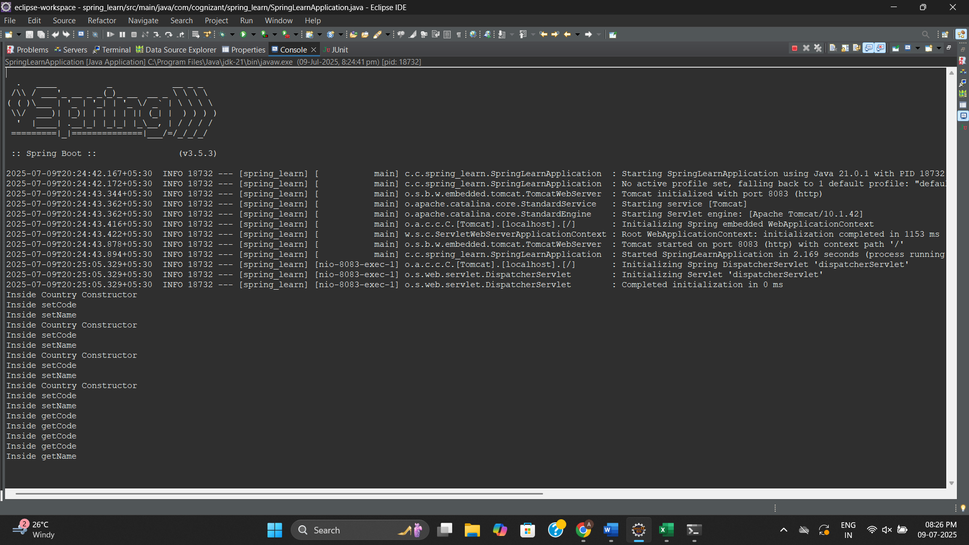

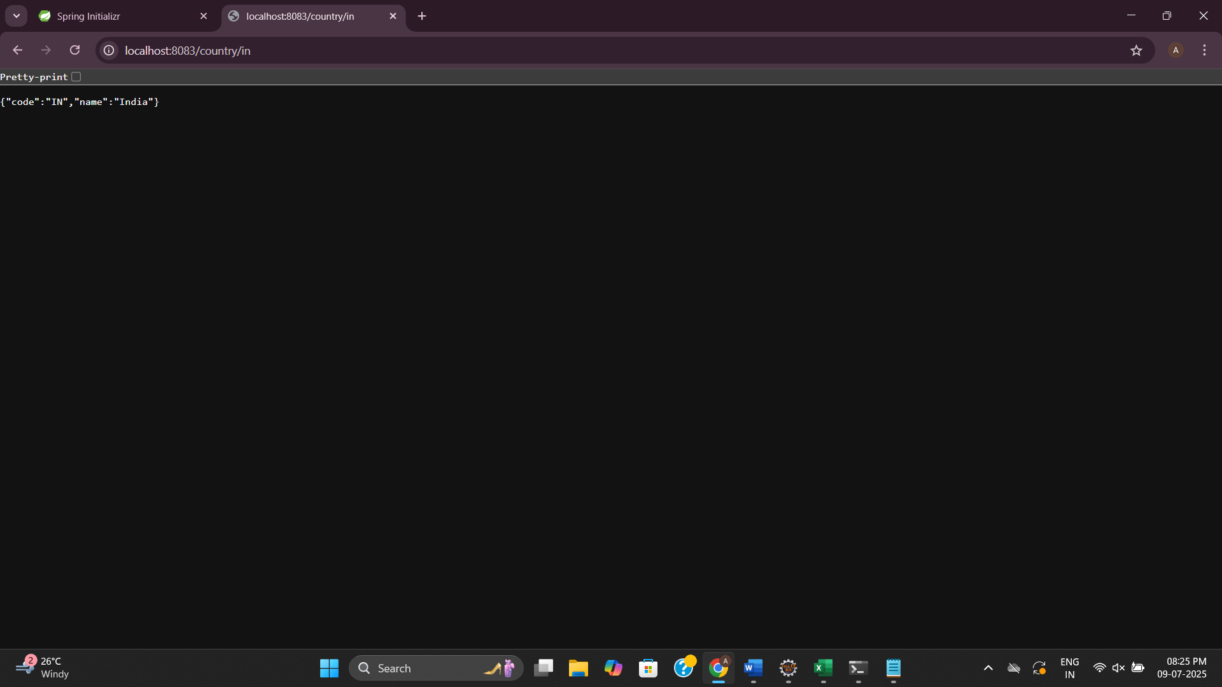

**Create authentication service that returns JWT**

**AuthenticationController.java**

package com.cognizant.jwtauthservice.controller;

import com.cognizant.jwtauthservice.service.JwtService;

import org.springframework.beans.factory.annotation.Autowired;

import org.springframework.http.*;

import org.springframework.web.bind.annotation.*;

import java.nio.charset.StandardCharsets;

import java.util.*;

*@RestController*

public class AuthenticationController {

*@Autowired*

private JwtService jwtService;

*@GetMapping*("/authenticate")

public ResponseEntity<?> authenticate(*@RequestHeader*("Authorization") String authHeader) {

if (authHeader == null || !authHeader.startsWith("Basic ")) {

return ResponseEntity.*status*(*HttpStatus*.***UNAUTHORIZED***).body("Missing or invalid Authorization header");

}

String base64Credentials = authHeader.substring("Basic ".length()).trim();

byte[] decoded = Base64.*getDecoder*().decode(base64Credentials);

String credentials = new String(decoded, StandardCharsets.***UTF_8***);

String[] values = credentials.split(":", 2);

String username = values[0];

String password = values[1];

if ("user".equals(username) && "pwd".equals(password)) {

String token = jwtService.generateToken(username);

return ResponseEntity.*ok*(Collections.*singletonMap*("token", token));

} else {

return ResponseEntity.*status*(*HttpStatus*.***UNAUTHORIZED***).body("Invalid credentials");

}

}

}

**JwtService.java**

package com.cognizant.jwtauthservice.service;

import io.jsonwebtoken.Jwts;

import io.jsonwebtoken.SignatureAlgorithm;

import io.jsonwebtoken.security.Keys;

import org.springframework.stereotype.Service;

import java.nio.charset.StandardCharsets;

import java.security.Key;

import java.util.Date;

*@Service*

public class JwtService {

private final Key key = Keys.*hmacShaKeyFor*(

"my-super-secret-key-which-should-be-256-bits!".getBytes(StandardCharsets.***UTF_8***)

);

public String generateToken(String username) {

return Jwts.*builder*()

.setSubject(username)

.setIssuedAt(new Date())

.setExpiration(new Date(System.*currentTimeMillis*() + 1000 * 60 * 10)) // 10 mins

.signWith(key, *SignatureAlgorithm*.***HS256***)

.compact();

}

}

**SecurityConfig.java**

package com.cognizant.jwtauthservice.config;

import org.springframework.context.annotation.Bean;

import org.springframework.context.annotation.Configuration;

import org.springframework.security.config.annotation.web.builders.HttpSecurity;

import org.springframework.security.web.SecurityFilterChain;

*@Configuration*

public class SecurityConfig {

*@Bean*

public SecurityFilterChain securityFilterChain(HttpSecurity http) throws Exception {

http

.csrf().disable()

.authorizeHttpRequests()

.requestMatchers("/authenticate").permitAll()

.anyRequest().authenticated();

return http.build();

}

}

**JwtauthserviceApplication.java**

package com.cognizant.jwtauthservice;

import org.springframework.boot.SpringApplication;

import org.springframework.boot.autoconfigure.SpringBootApplication;

*@SpringBootApplication*

public class JwtauthserviceApplication {

public static void main(String[] args) {

SpringApplication.*run*(JwtauthserviceApplication.class, args);

}

}

**pom.xml**

<?xml version="1.0" encoding="UTF-8"?>

<project xmlns="http://maven.apache.org/POM/4.0.0" xmlns:xsi="http://www.w3.org/2001/XMLSchema-instance"

xsi:schemaLocation="http://maven.apache.org/POM/4.0.0 https://maven.apache.org/xsd/maven-4.0.0.xsd">

<modelVersion>4.0.0</modelVersion>

<parent>

<groupId>org.springframework.boot</groupId>

<artifactId>spring-boot-starter-parent</artifactId>

<version>3.5.3</version>

<relativePath/> <!-- lookup parent from repository -->

</parent>

<groupId>com.cognizant</groupId>

<artifactId>jwtauthservice</artifactId>

<version>0.0.1-SNAPSHOT</version>

<name>jwtauthservice</name>

<description>Demo project for Spring Boot</description>

<url/>

<licenses>

<license/>

</licenses>

<developers>

<developer/>

</developers>

<scm>

<connection/>

<developerConnection/>

<tag/>

<url/>

</scm>

<properties>

<java.version>17</java.version>

</properties>

<dependencies>

<dependency>

<groupId>org.springframework.boot</groupId>

<artifactId>spring-boot-starter-security</artifactId>

</dependency>

<dependency>

<groupId>org.springframework.boot</groupId>

<artifactId>spring-boot-starter-web</artifactId>

</dependency>

<dependency>

<groupId>org.springframework.boot</groupId>

<artifactId>spring-boot-devtools</artifactId>

<scope>runtime</scope>

<optional>true</optional>

</dependency>

<dependency>

<groupId>org.springframework.boot</groupId>

<artifactId>spring-boot-starter-test</artifactId>

<scope>test</scope>

</dependency>

<dependency>

<groupId>org.springframework.security</groupId>

<artifactId>spring-security-test</artifactId>

<scope>test</scope>

</dependency>

<!-- JJWT dependencies -->

<dependency>

<groupId>io.jsonwebtoken</groupId>

<artifactId>jjwt-api</artifactId>

<version>0.11.5</version>

</dependency>

<dependency>

<groupId>io.jsonwebtoken</groupId>

<artifactId>jjwt-impl</artifactId>

<version>0.11.5</version>

<scope>runtime</scope>

</dependency>

<dependency>

<groupId>io.jsonwebtoken</groupId>

<artifactId>jjwt-jackson</artifactId>

<version>0.11.5</version>

<scope>runtime</scope>

</dependency>

</dependencies>

<build>

<plugins>

<plugin>

<groupId>org.springframework.boot</groupId>

<artifactId>spring-boot-maven-plugin</artifactId>

</plugin>

</plugins>

</build>

</project>

**Output:**

